Python programing

Expt 02:Code execute and debug different input and output statement, execute expression and display the result.

**2a:** Write a python program for swap a variable value.

**Code:** x=5

y=7

z=10

print("before swapping")

print("value of x and y and z",x,y,z)

temp=x

x=y

y=z

z=temp

print("after swapping")

print("value of x and y and z",x,y,z)

**Output:**

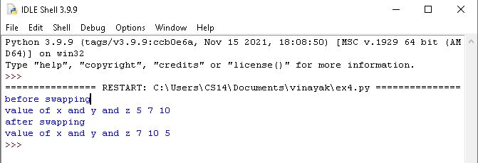

**2b**:Write python program for quadratic equation.

**Code:**

import cmath

a=1

b=5

c=6

d=(b**2)-(4*a*c)

ans1=(-b- cmath.sqrt(d))/(2*a)

ans2=(-b+ cmath.sqrt(d))/(2*a)

print("the solution is",ans1,ans2)

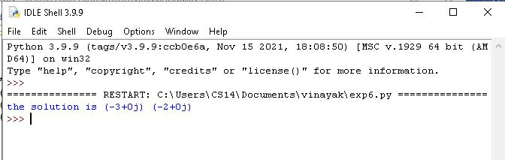**Output:**

**2c**: Write a python progrom to different basic arithmetic operation.

**Code:**

x=int(input("enter number1:"))

y=int(input("enter number2:"))

sum=x+y

print("the addition is=",sum)

sub=x-y

print("the substraction is=",sub)

mul=x*y

print("the multiplication is=",mul)

div=x/y

print("the division is=",div)

**Output:**

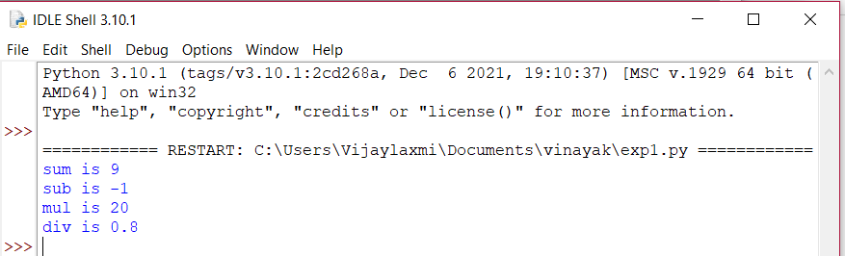

**EXP03**: Identify and code execute by using conditional statement.

**3A:** Write a python program for find largest of 3 number.

**Code:**

a=int(input("enter value of a"))

b=int(input("enter value of b"))

c=int(input("enter value of c"))

if a>b and a>c:

print("a is largest")

if b>a and b>c:

print("b is largest")

if c>a and c>b:

print("c is largest")

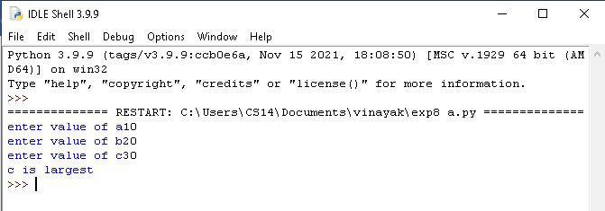**Output:**

**EXP3b:**Write a python program for to check given value is pass or fail.

**Code:** marks=int(input("enter your marks"))

if marks>=35:

print("I am pass")

else:

print("I am fail")

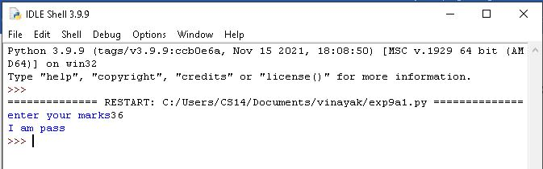**output**

**EXPT3C:**Write a python program to identify the given value is positive, negative or zero by using ‘IF ELSE IF’ statement.

**Code:** num=-10

if num>0:

print("number is positive")

elif num<0:

print("number is negative")

else:

print("number is zero")

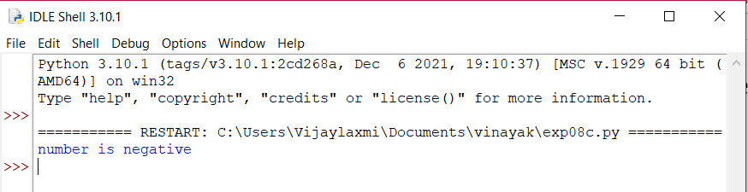**Output:**

**EXPT04:**Code execute and debug the programs by using lops and conditional statements.

4a:Execute and perform python program by using looping statement.

**Code:** n=int(input("enter the numbers"))

for i in range(1,11):

c=n*i

print(n,"*",i,"=",c)

**Output:**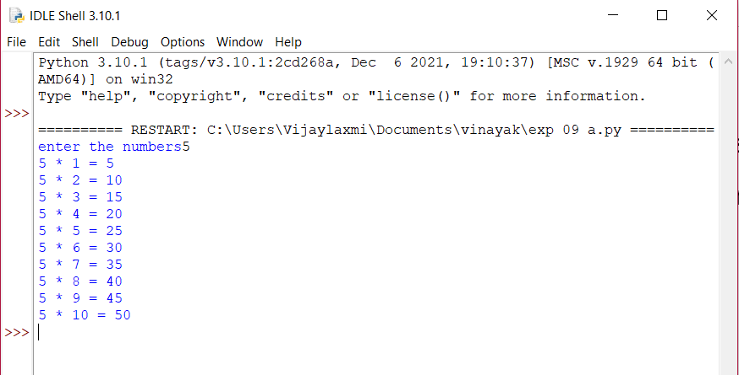

**Expt4b:**Write a python program for implement addition of 10 natural number by using while looping statement.

**Code:** i=1

while(i<=10):

print(i)

i=i+1

**Output:**

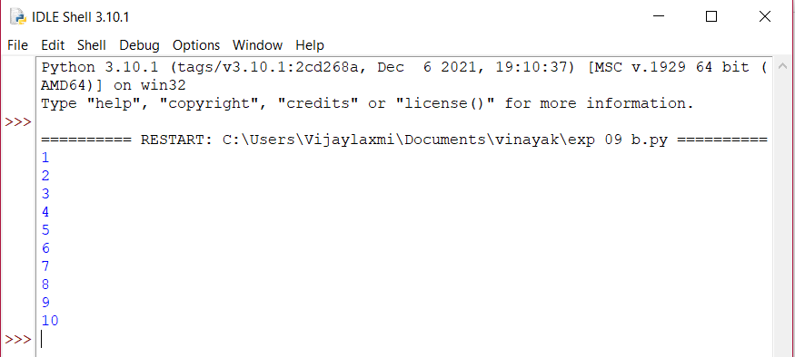

**EXPT4C:**write a python program to perform addition of first natural by using while looping statement.

**Code:** n=10

sum=0

i=1

while i <=n:

sum=sum+i

i=i+1

print("the sum of natural number is",sum)

**Output:**

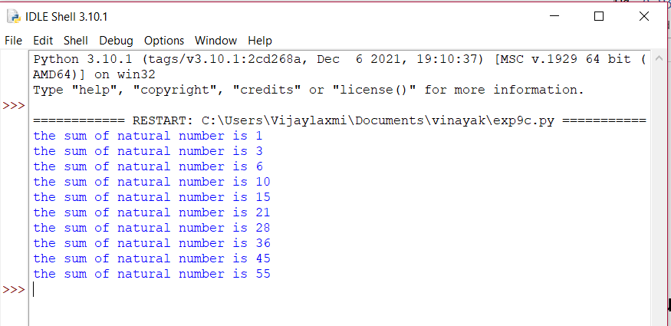

**EXPT05:**Code execute and debug the programs by using SET operations and TUPLES.

**EXPT5A**:Python program for SET operations.

**Code:**

months=set(["january","february","march","april","may","june"])

print("the original set")

print (months)

print("adding other momths to the set")

months.add("july")

months.add("agust")

months.add("september")

months.add("0ctober")

months.add("november")

months.add("december")

print("printing modified set")

print(months)

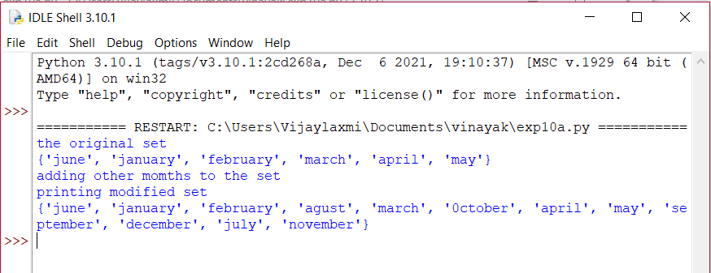**Output:**

**EXPT5B:**Python program for UNION method.

**Code:** set1={'python','java'}

set2={'c++','java','pgmc'}

set=set1.union(set2)

print(set)

**Output:**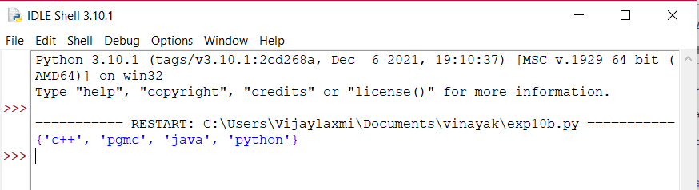

**EXPT5C:**Python program for INTERSECTION method.

**Code:**

set1={'python','java'}

set2={'c++','java','pgmc','python'}

set=set1.intersection(set2)

print(set)

**Output:**

